How Does DNA Determine the Traits of an Organism?
In this simulation, you will examine the DNA sequence of a made up organism, the Snork. Snorks were discovered on the planet Dee Enae in a distant solar system. Snorks only have one chromosome with 6 genes on it. Your job is to analyze the genes of its DNA and determine what traits the organism has. Amazingly the snork uses the same method of protein synthesis as humans do (must be universal). Use the charts below to figure out what the snork looks like and draw it in your notebook.

SNORK DNA AND TRAITS

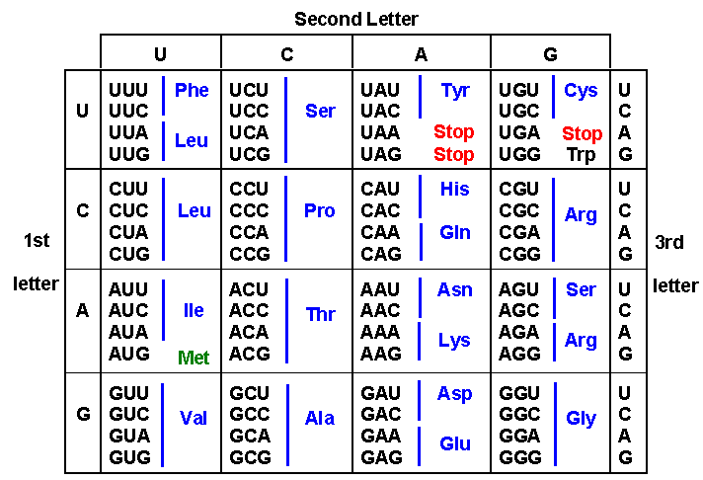

AMINO ACID SEQUENCE | TRAIT
ser – pro – ile | Hairless
Trp – pro – ile | Hairy
Ser – ala – pro | Plump
ser – ala – gly | Skinny
Arg – leu – glu | 4 legged
Lys – leu – phe | 6 Legged
Pro – ala – ala | Triangle Head
Pro – lys – ile | Star head
Pro – ser – phe | No tail
Pro – thr – met | Tail
Gly – gly – asp | Wide square eyes
Tyr – tyr – asp | Narrow rectangle eyes

Below is the DNA sequence of a snork. Each gene has only 3 amino acids. Your job is to determine the mRNA sequence from the DNA, then the amino acids (protein), and finally the trait. After you have done this draw your SNORK in your notebook. Answer the finally question about mutations as well.

DNA | ACCGGTTAT/AGCCGAGGG/TTTAACAAA/GGACGCCGA/GGGAGGAAA/ATAATACTA
mRNA
AA
Trait

QUESTIONS – answer in your notebook
- Draw your snork
- What would happen to the order of the amino acids if the first C in the DNA becomes a G? Would this change the trait? Explain
- What would happen to the order of the amino acids if the first T in the DNA becomes a G? would this change the trait? explain
- When one base pair in DNA changes to become another it is called a mutation. Based on your answer to #1 and #2 why are some mutations dangerous and others not?

