Name ______________________ Period _________

Monster Cell Test: Study Guide

VOCABULARY to Define:

- Prokaryote
- Eukaryote
- Organelle
- Cytoplasm
- Nucleus
- Endoplasmic reticulum
- Ribosome
- Golgi body
- Mitochondria
- Vacuole
- Cell wall
- Chloroplast
- Cell membrane
- Phospholipid
- Diffusion
- Concentration gradient
- Passive transport
- Active transport
- Mitosis
- Cytokinesis
- ATP/ADP
- C₆H₁₂O₆
- Chlorophyll
- Glycolysis
- Aerobic
- Anaerobic

QUESTIONS TO ANSWER:

- Which is correct? Products reactants OR reactants products?
- Is bacteria a prokaryote or a eukaryote?
- Is a tree a prokaryote or a eukaryote?
- What is an organelle?
- When water moved into and out of the plant cell in our lab, was this passive transport or active transport?
  - Was it diffusion?
  - Was it osmosis?
  - Was there a concentration gradient?
- Why does an unwrapped carrot or piece of celery get soft or floppy after it is stored in the refrigerator? Use the word “osmosis” in your answer.
- Describe why the words “selectively permeable” refer to a tea bag.
- What is the main function of a cell membrane?
- What is the cell cycle?
- What happens during each phase of the cell cycle?
- How is mitosis different from cytokinesis?
- Why do we need to make ATP instead of just using glucose as energy for our cells?
- Does not require oxygen (aerobic or anaerobic)
- Requires oxygen (aerobic or anaerobic)
- What is the main goal of photosynthesis?
- What is the equation for photosynthesis? What two molecules go into the photosynthesis equation? What are the products?
- What is the main goal of cellular respiration?
- What is the equation for cellular respiration?
- Glycolysis means to split sugar, what process is it a part of?
- What is the name of this reaction? C₆H₁₂O₆ + 6O₂ 6H₂O + 6CO₂ + energy
  - What are the reactants?
  - What are the products?
  - On what organelle does this happen?
- What is it called when your muscles do not have enough oxygen?
- What is it called when yeast do not have oxygen (like in the brewing of wine or root beer)?
- Eukaryotes contain structures that act as if they are specialized organs. These structures are called ___________________.
- Molecules tend to move from an area where they are more concentrated to an area where they are less concentrated. This process is called ___________________.

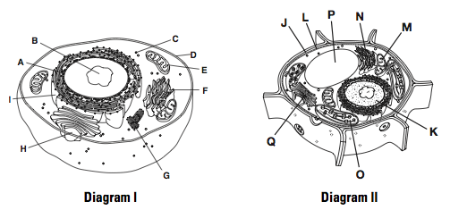

- What is shown in Diagram 1?
- What is shown in Diagram 2?
- Give the label letters and full names of two structures that are found in a plant cell but not in an animal cell. State the function of each of these structures.
- Which diagram above contains a structure that captures sunlight and converts it into chemical energy? What is the name of the structure described?
- Which organelle in Diagram 1 does cellular respiration?
- Does Diagram 2 do cellular respiration? If so, which letter represents the organelle where it happens?
- Identify which phrase describes the following processes:
cellular respiration, glycolysis, lactic acid fermentation, or alcoholic fermentation
  - builds up in muscles after intense activity
  - requires oxygen and glucose
  - Important in brewing wine or beer
  - almost the opposite process of photosynthesis
  - the reason why runners breathe heavily after a race

