Feline Fakebook Profile…
Instead of doing a traditional report on your feline species, we will share our findings in a fake Facebook format. You do not need a Facebook account for this assignment – instead we will be using a special interface designed specifically for education.
- Before you begin, you will need to select and research your feline species.
- We will be choosing our species from the list of 35 cats on the Felidae website (http://www.felidaefund.org/?q=species-list).
- Take the information you learn about your cat, and use it to complete your Fakebook profile. Please use the directions below.
- Type the URL http://classtools.net/fb/home/page in your internet browser.
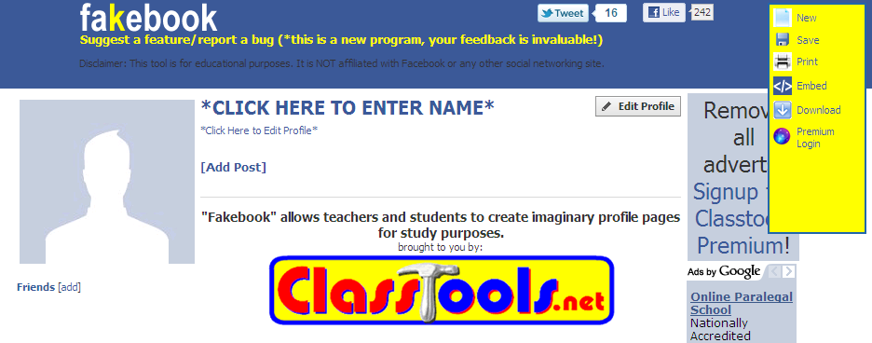
- Enter your Cat species under the blue banner *CLICK HERE TO ENTER NAME*
- Leave “select an Image as Autoselect” and click Submit. A picture of your cat will fill in if available. If you want to add a custom picture, you will need to save the picture to the computer, then choose Upload from my computer. Browse to where the picture is saved and upload.
- Edit Profile and complete information required following the format required
  - Scientific Name (Genus species)
  - Distribution
  - Habitat
  - Diet
  - Size / weight
  - Any other ideas are welcome…
- Add friends – click [add] by Friends
  - Add a “friend” for each type of prey.
  - Add a friend for at least 3 other animals that are found in the same habitat as your cat.
  - Add a friend for at least 2 types of plants that are found in your cat’s habitat
  - Repeat to add additional feline relationships.

- Add a minimum of 3 Posts – click add posts
  - Enter the poster’s name: These could be conversations between predators and prey, between cats of the same species, etc…
  - Enter content
  - Enter date of post
  - You can leave the image default for the picture
  - Click Share when you are finished.
  - Repeat for additional posts

- Add comments – click add comment
  - Follow the same instructions as a post
  - Enter name, comment, date and click share
  - Repeat for additional comments

- Be sure to save often. Your password is only entered once and remains the same throughout. Don’t lose the URL back to your work, it’s the only way to return to your project! Use the tools on the right to start new, save, print, etc. Ignore Premium Login, we don’t have access to this!

Notes: You can save your work AFTER you have created the name, profile, friend and a post. You pick the password and they will give you a URL to come back to your work. Be sure to copy this information into a word document or email to yourself so you can get back to your work later (or at home)! Save often!

